**Reviewing (Role: Reviewer)**

**Sales => Reports**

* On this section Reviewer can view order on reviewing stage.

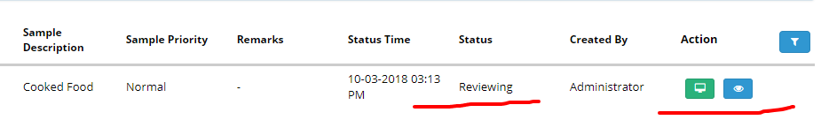

When user click on the review report button, a new window will appear here.

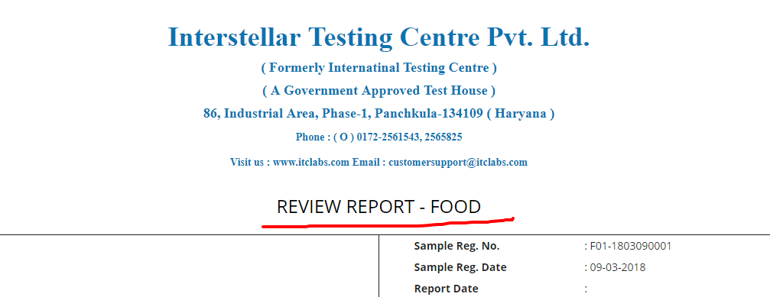

**Part A shows information about the sample.**

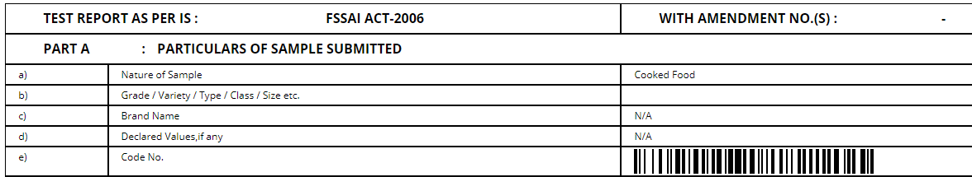

Part B: **SUPPLIMENTARY INFORMATIONS (Mandatory):**

All these field are mandatory and user need to select from the DROPDOWN.

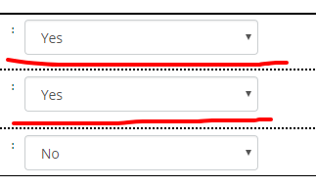

If Reviewer find the result is incorrect than user can click on the checkbox than need modification button will be appear here, than again the selected parameter will move to the tester.

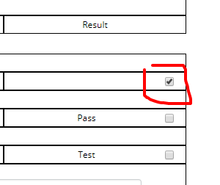

And button will change.



And a popup window will appear here where reviewer need to add the notes about the modification.

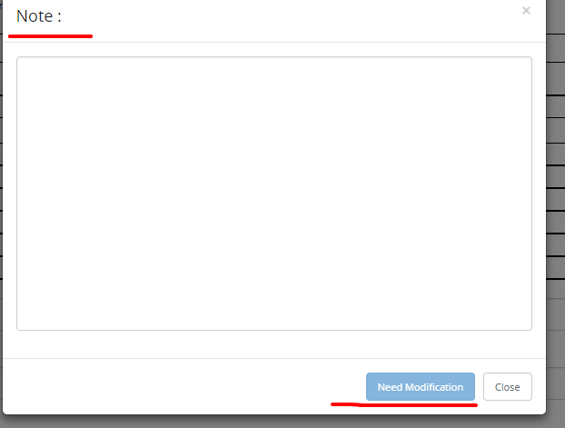

Part C section is result section, reviewer need to verify the result posted by the Tester.

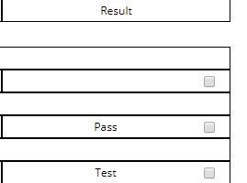

Remarks section is also mandatory, need to select from the dropdown than enter the notes.

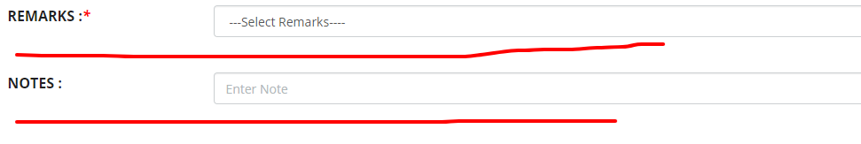

* When user filled the entire mandatory field than click on the save button.
* After saving the detail again user need to come on the same window and confirm the result.
* After confirm the result sample record will updated.
* Sample will move for the finalizing process to finalizer.